Practice Questions

1. What is Python programming?

- A snake

- A high level programming language

- Code to create X-Box games

- A computer program to search for names

1. What is an algorithm?

- A way of knowing how to program

- A set of instructions to solve a problem

- A set of problems that need to be solved

- Problems that computers can not solve

1. Why do we use algorithms?

- To be good at programming

- To have a set of instructions to help us program a solution

- So there are many solutions to problems

- So calculate the total sums

1. Which is the correct code for asking someone where they are from?
2. Is the answer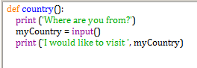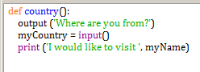
3. From question 4, if **myCountry** is equal to **Spain**, what would the program output?

- Spain is the best

- Spain is hot

- I would like to visit Spain

- Where are you from Spain